A paper review about “Planning and Control of Ensembles of Robots with Non-holonomic Constraints” by Nathan Michael and Vijay Kumar

Huang Yu

1. **Goal**

This paper mainly is focused on the basic problem of controlling the position and orientation of mobile robots` formation and adaptation of the shape to the environment. It devised an approach of collision avoidance without unnecessary complexity added to the system. Besides, it also considered planning for the shape and trajectory of the ensemble.

1. **Assumptions**

In order to formulate an abstract state which is the basis for later discussion, the paper assumed that there is a global observation of the abstract state. Although it requires an additional device, the paper pointed out the possibility of developing an estimator for individual robots to estimate their abstract states. See Figure1.

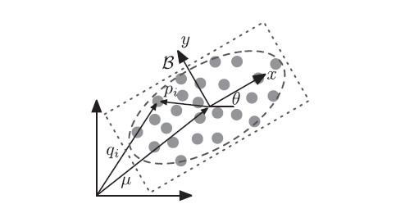

Fig.1. [1] in order to obtain the abstraction of the formation, we need an observer. Based on the data detected, we can determine the centroid.

1. **Limitations**

The paper initially introduced the background of the idea along with some terminologies included such as abstract map, centroid and proposed a collision avoidance requirement with the proof of asymptotic convergence under this requirement. For the second part of the paper, it proposed an energy metric for motion planning of a deformable ellipse.

The hardware experiments also demonstrated waypoint control and ensemble merging. However the convergence control and the trajectory control did not guarantee the control time nor did it propose an approach to estimate time. The implementation also requires an extra global observer. For the future work, the distributed estimation algorithm is a promising solution.

[1] N. Michael, V. Kumar, “Planning and Control of Ensembles of Robots with Non-holonomic Constraints”. The International Journal of Robotics ResearchJune 26, 2009